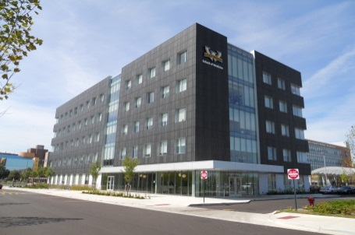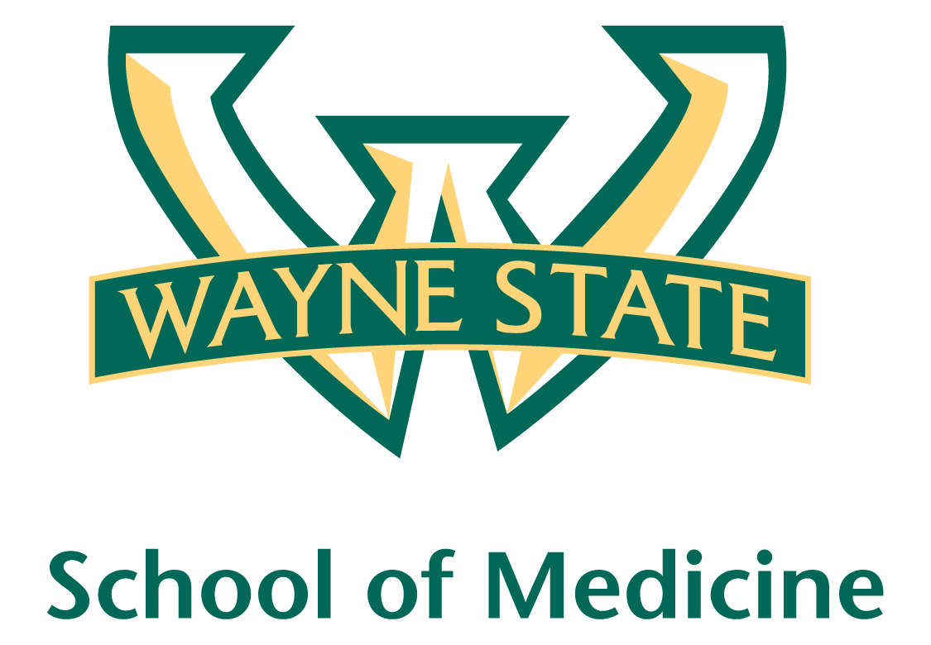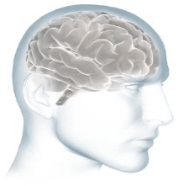

**Department of Psychiatry & Behavioral Neurosciences**

**Office of Education and Training Programs**

Continuing Medical Education

|  |  |  |  |  |
| --- | --- | --- | --- | --- |
| **CHAIRMAN’S GRAND ROUNDS**  **March 2021 Presentation Schedule** | | | Venue:  ZOOM Conference (Details will be emailed out weekly)  Time: 1-2pm | |
| **DATE:** | **SPEAKER/BACKGROUND:** | **TOPIC:** | | **OBJECTIVES:** |
| **March 3, 2021** | **Hayley Getzen, MD, MPH**  Resident  General Psychiatry Residency Program  Dept. of Psychiatry & Behavioral Neurosciences  Wayne State University School of Medicine  *Discussant: Dr. Fahd A. Syed* | **“Sorting Through Senile Squalor”** | | 1. Identify the clinical features of self-neglect and squalor in the geriatric population. 2. Recognize psychiatric and medical comorbidities associated with squalor syndromes. 3. Review literature relevant to the breakdown in personal and environmental hygiene standards. 4. Differentiate squalor syndromes from other psychiatric illnesses, including hoarding disorder. 5. Discuss the assessment and management of elderly individuals living in squalor. |
| **March 10, 2021** | **Adrienne Lahti, M.D.**  Professor and Chair  Dept. of Psychiatry and Behavioral Neurobiology  The University of Alabama at Birmingham (UAB) | **“Brain Imaging Studies in the Psychosis Spectrum”** | | 1. Identify which behavioral and brain imaging measures are predictive of treatment response to antipsychotic medication. 2. Identify which brain imaging measures are impacted by a long duration of untreated psychosis. 3. Describe the mechanism by which brain glutamate can impact the size of the hippocampus. |
| **March 17, 2021** | **Tehmina Shakir, M.D., CCP**  Assistant Professor-Clinical Education  Dept. of Psychiatry & Behavioral Neurosciences  Wayne State University School of Medicine | **“Juvenile Sex Offenders: Theory, Evaluation and Treatment”** | | At the end of this presentation, the learners will be able to:   1. Describe patterns of sexual offending in juveniles and risk factors for recidivism. 2. List recommended parameters for evaluation and risk assessment of sexually offending youth. 3. List treatment options for sexually offending behavior. 4. Describe trends in Juvenile Justice and Criminal Management of juvenile sex offenders. |
| **March 24, 2021** | **Jeffrey Stanley, Ph.D.**  Professor  Dept. of Psychiatry & Behavioral Neurosciences  Wayne State University School of Medicine | **“Direct Evidence of Impaired Modulation of Hippocampal Glutamate during Memory Consolidation in Schizophrenia using 1H fMRS”** | | 1. Introduce the glutamatergic hypo-function hypothesis as a key neural mechanism mediating learning and memory deficits in schizophrenia. 2. Introduce 1H fMRS and its conceptual framework as an emerging tool for assessing task-related changes in the excitatory neurotransmitter glutamate in function. 3. Provide evidence of dysfunctional modulation of hippocampal glutamate in SZ patients during memory consolidation and its clinical relevance. |
| **March 31, 2021** | **Hiba Abu Suhaiban, M.D.**  Resident  General Psychiatry Residency Program  Dept. of Psychiatry & Behavioral Neurosciences  Wayne State University School of Medicine  *Discussant: Dr. Sumi Cyriac* | **“Adolescent-Onset Psychosis:**  **How Much Do We Know?”** | | 1. Identify the clinical characteristics of psychosis in Adolescents. 2. Describe the evaluation process of children and adolescents with psychotic symptoms. 3. Discuss the treatment of psychosis in Adolescents. |
| “The Wayne State University School of Medicine is accredited by the Accreditation Council for  Continuing Medical Education to provide continuing medical education for physicians.  The Wayne State University School of Medicine designates this live activity for a maximum of 1 hour ***AMA PRA Category 1 Credit(s)TM***Physicians should claim only credit commensurate with the extent of their participation in the activity.”  Attending Audience: Approximately 75 (plus) individuals, including psychiatrists, psychologists, social workers, researchers, nurses, psychiatry faculty and trainees in the Dept. of Psychiatry & Behavioral Neurosciences, Wayne State University School of Medicine.  The Department of Psychology at Wayne State University is approved by the American Psychological Association to sponsor continuing education for psychologists. The Department of Psychology at Wayne State University maintains responsibility for this program and its content. Please direct questions about continuing education to Dr. Mark Lumley at: [mlumley@wayne.edy](mailto:mlumley@wayne.edy) or 313.577.2247. | | | **“CME Transcripts may be accessed at**  **cme.med.wayne.edu**  Questions related to CME Transcripts call: (313) 577.5410 or  email: [dcme@med.wayne.edu](mailto:jessica.washington@pmkbnc.com)  WSU/DPBN Chairman’s Grand Rounds - CME contacts:  *Chair: David Rosenberg, M.D.*  *CME Director: Richard Balon, M.D.*  [rbalon@wayne.edu](mailto:rbalon@wayne.edu)  *Coordinator: Michelle Trevithick*  [mtrevith@med.wayne.edu](mailto:mtrevith@med.wayne.edu)  Office: (313) 577-5283 or Fax: (313) 577-2233  <https://psychiatry.med.wayne.edu/> | |